**Task No: 1**

#include <iostream>

using namespace std;

int main()

{

int n, addition = 0;

int i = 1;

cout << "Enter the numbers to add: ";

cin >> n;

while (i <= n)

{

addition = addition + i;

i+=1;

}

cout << "The sum of first " << n << " natural numbers is: " << addition << endl;

return 0;

}

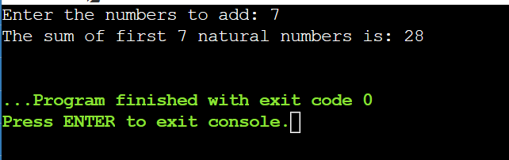

**Task No: 2**

#include <iostream>

using namespace std;

int main()

{

int integer;

cout << "Enter the number: ";

cin >> integer;

cout << "The table of " << integer << " is:" << endl;

for (double z = 1; z <= 100; z++)

{

cout << integer << " x " << z << " = " << integer * z<< endl;

}

return 0;

}

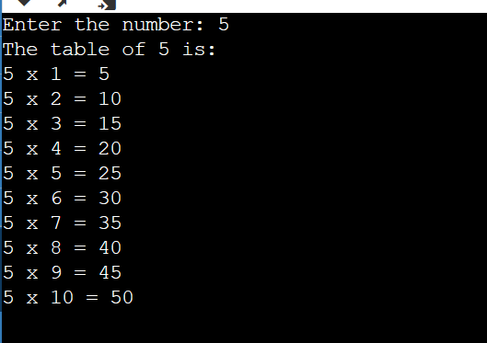

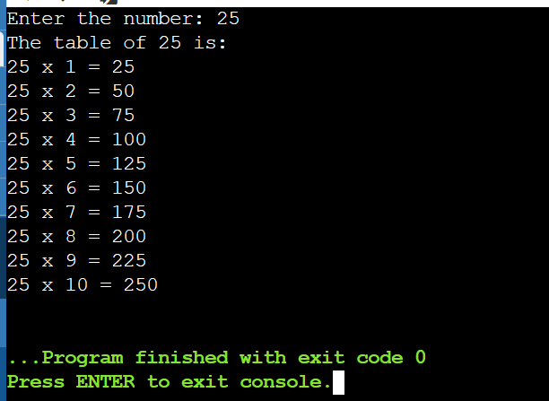

**Task No: 3**

#include <iostream>

using namespace std;

int main()

{

int p;

cout << "Enter a number: ";

cin >> p;

int factorial = 1;

for (int i = 1; i <= p; i++)

{

factorial = factorial * i;

}

cout << "Factorial of " << p << " is: " << factorial<< endl;

return 0;

}

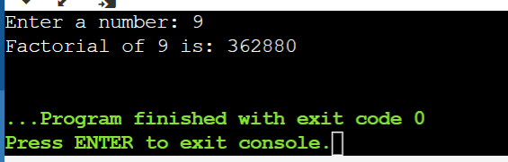

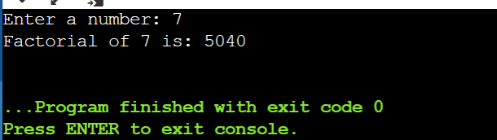

**Task No: 4**

#include <iostream>

using namespace std;

int main()

{

int num, first = 0, second = 1, next;

cout << "Enter a natural number: ";

cin >> num;

cout << "Fibonacci sequence up to " << num << " is: " << endl;

while (first <= num)

{

cout << first << " ";

next = first + second;

first = second;

second = next;

}

return 0;

}

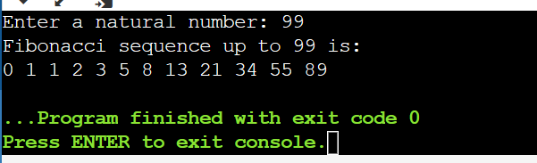

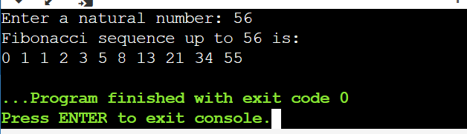

**THE END**